Experiment No: 9 Date: 15-10-2024

**Implementation of FIR Filters**

**Aim:** Write a MATLAB program to implement the following FIR filters using Hanning, Hamming, Rectangular and Triangular windows.

1. Low Pass Filter
2. High Pass Filter
3. Band Pass Filter
4. Band Stop Filter

**Theory**

Finite Impulse Response (FIR) filters are a type of digital filter characterized by a finite duration of the impulse response. The window method is a common technique used to design FIR filters. This method involves multiplying an ideal (infinite) impulse response by a window function to create a realizable FIR filter. The FIR filter coefficients h[n] are obtained by multiplying the ideal impulse response by the chosen window function. The frequency response of the FIR filter can be analyzed using the Discrete Fourier Transform (DFT). The window function influences the main lobe width and side lobe levels in the frequency response. A narrower main lobe provides better frequency resolution, while lower side lobes reduce spectral leakage.

Windows:

Filters:

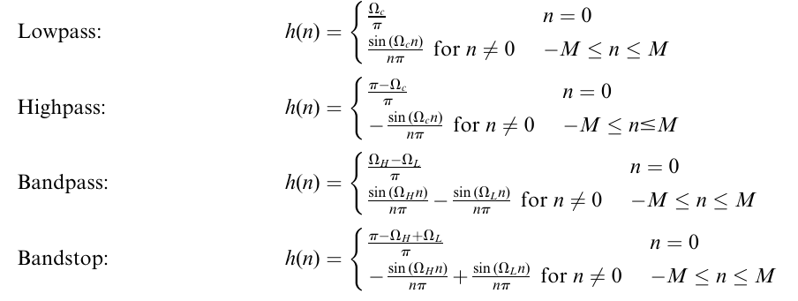

**Program**

1. Low Pass Filter

wc = 0.5*pi;

N=50;

alpha = (N-1)/2;

n=0:1:N-1;

hd=sin(wc*(n-alpha))./(pi*(n-alpha));

%LPFhamming

w1=hamming(N);

hn=hd.*w1';

w=0:0.01:pi;

h1=freqz(hn,1,w);

subplot(4,2,1);

plot(w/pi,10*log10(abs(h1)));

title('LPF using hamming window');

xlabel('normalized frequency');

ylabel('magnitude in db');

%LPFhanning

w2=hanning(N);

hn=hd.*w2';

w=0:0.01:pi;

h2=freqz(hn,1,w);

subplot(4,2,3);

plot(w/pi,10*log10(abs(h2)));

title('LPF using hanning window');

xlabel('normalized frequency');

ylabel('magnitude in db');

%LPFrect

w3=boxcar(N);

hn=hd.*w3';

w=0:0.01:pi;

h3=freqz(hn,1,w);

subplot(4,2,5);

plot(w/pi,10*log10(abs(h3)));

title('LPF using rectangular window');

xlabel('normalized frequency');

ylabel('magnitude in db');

%LPFtri

w4=bartlett(N);

hn=hd.*w4';

w=0:0.01:pi;

h4=freqz(hn,1,w);

subplot(4,2,7);

plot(w/pi,10*log10(abs(h4)));

title('LPF using triangular window');

xlabel('normalized frequency');

ylabel('magnitude in db');

%hamming

subplot(4,2,2);

stem(w1);

title('hamming window sequence');

xlabel('no of samples');

ylabel('amplitude');

%hanning

subplot(4,2,4);

stem(w2);

title('hanning window sequence');

xlabel('no of samples');

ylabel('amplitude');

%rectangular

subplot(4,2,6);

stem(w3);

title('rectangular window sequence');

xlabel('no of samples');

ylabel('amplitude');

%triangular

subplot(4,2,8);

stem(w4);

title('tirangular window sequence');

xlabel('no of samples');

ylabel('amplitude');

1. High Pass Filter

clc;

clear all;

close all;

wc = 0.5*pi;

N=50;

alpha = (N-1)/2;

n=0:1:N-1;

hd=(sin(pi*(n-alpha))-sin(wc*(n-alpha)))./(pi*(n-alpha));

%HPFhamming

w1=hamming(N);

hn=hd.*w1';

w=0:0.01:pi;

h1=freqz(hn,1,w);

subplot(4,2,1);

plot(w/pi,10*log10(abs(h1)));

title('HPF using hamming window');

xlabel('normalized frequency');

ylabel('magnitude in db');

%HPFhanning

w2=hanning(N);

hn=hd.*w2';

w=0:0.01:pi;

h2=freqz(hn,1,w);

subplot(4,2,3);

plot(w/pi,10*log10(abs(h2)));

title('HPF using hanning window');

xlabel('normalized frequency');

ylabel('magnitude in db');

%HPFrect

w3=boxcar(N);

hn=hd.*w3';

w=0:0.01:pi;

h3=freqz(hn,1,w);

subplot(4,2,5);

plot(w/pi,10*log10(abs(h3)));

title('HPF using rectangular window');

xlabel('normalized frequency');

ylabel('magnitude in db');

%HPFtri

w4=bartlett(N);

hn=hd.*w4';

w=0:0.01:pi;

h4=freqz(hn,1,w);

subplot(4,2,7);

plot(w/pi,10*log10(abs(h4)));

title('HPF using triangular window');

xlabel('normalized frequency');

ylabel('magnitude in db');

%WINDOWS

%hamming

subplot(4,2,2);

stem(w1);

title('hamming window sequence');

xlabel('no of samples');

ylabel('amplitude');

%hanning

subplot(4,2,4);

stem(w2);

title('hanning window sequence');

xlabel('no of samples');

ylabel('amplitude');

%rectangular

subplot(4,2,6);

stem(w3);

title('rectangular window sequence');

xlabel('no of samples');

ylabel('amplitude');

%triangular

subplot(4,2,8);

stem(w4);

title('tirangular window sequence');

xlabel('no of samples');

ylabel('amplitude');

1. Band Pass Filter

clc;

clear all;

close all;

wcl= 0.25*pi;

wc2 = 0.75*pi;

N=50;

%N = input('enter the value of N');

alpha = (N-1)/2;

n=0:1:N-1;

hd=(sin(wcl*(n-alpha+eps))-sin(wc2*(n-alpha+eps)))./(pi*(n-alpha+eps));

%BPFhamming

w1=hamming(N);

hn=hd.*w1';

w=0:0.01:pi;

h1=freqz(hn,1,w);

subplot(4,2,1);

plot(w/pi,10*log10(abs(h1)));

title('BPF using hamming window');

xlabel('normalized frequency');

ylabel('magnitude in db');

%BPFhanning

w2=hanning(N);

hn=hd.*w2';

w=0:0.01:pi;

h2=freqz(hn,1,w);

subplot(4,2,3);

plot(w/pi,10*log10(abs(h2)));

title('BPF using hanning window');

xlabel('normalized frequency');

ylabel('magnitude in db');

%BPFrect

w3=boxcar(N);

hn=hd.*w3';

w=0:0.01:pi;

h3=freqz(hn,1,w);

subplot(4,2,5);

plot(w/pi,10*log10(abs(h3)));

title('BPF using rectangular window');

xlabel('normalized frequency');

ylabel('magnitude in db');

%BPFtri

w4=bartlett(N);

hn=hd.*w4';

w=0:0.01:pi;

h4=freqz(hn,1,w);

subplot(4,2,7);

plot(w/pi,10*log10(abs(h4)));

title('BPF using triangular window');

xlabel('normalized frequency');

ylabel('magnitude in db');

%WINDOWS

%hamming

subplot(4,2,2);

stem(w1);

title('hamming window sequence');

xlabel('no of samples');

ylabel('amplitude');

%hanning

subplot(4,2,4);

stem(w2);

title('hanning window sequence');

xlabel('no of samples');

ylabel('amplitude');

%rectangular

subplot(4,2,6);

stem(w3);

title('rectangular window sequence');

xlabel('no of samples');

ylabel('amplitude');

%triangular

subplot(4,2,8);

stem(w4);

title('tirangular window sequence');

xlabel('no of samples');

ylabel('amplitude');

1. Band Stop Filter

wcl= 0.25*pi;

wc2 = 0.75*pi;

N=50;

%N = input('enter the value of N');

alpha = (N-1)/2;

n=0:1:N-1;

hd=(sin(wcl*(n-alpha+eps))-sin(wc2*(n-alpha+eps))+sin(pi*(n-alpha+eps)))./(pi*(n-alpha+eps));

%BSFhamming

w1=hamming(N);

hn=hd.*w1';

w=0:0.01:pi;

h1=freqz(hn,1,w);

subplot(4,2,1);

plot(w/pi,10*log10(abs(h1)));

title('BSF using hamming window');

xlabel('normalized frequency');

ylabel('magnitude in db');

%BSFhanning

w2=hanning(N);

hn=hd.*w2';

w=0:0.01:pi;

h2=freqz(hn,1,w);

subplot(4,2,3);

plot(w/pi,10*log10(abs(h2)));

title('BSF using hanning window');

xlabel('normalized frequency');

ylabel('magnitude in db');

%BSFrect

w3=boxcar(N);

hn=hd.*w3';

w=0:0.01:pi;

h3=freqz(hn,1,w);

subplot(4,2,5);

plot(w/pi,10*log10(abs(h3)));

title('BSF using rectangular window');

xlabel('normalized frequency');

ylabel('magnitude in db');

%BSFtri

w4=bartlett(N);

hn=hd.*w4';

w=0:0.01:pi;

h4=freqz(hn,1,w);

subplot(4,2,7);

plot(w/pi,10*log10(abs(h4)));

title('BSF using triangular window');

xlabel('normalized frequency');

ylabel('magnitude in db');

%WINDOWS

%hamming

subplot(4,2,2);

stem(w1);

title('hamming window sequence');

xlabel('no of samples');

ylabel('amplitude');

%hanning

subplot(4,2,4);

stem(w2);

title('hanning window sequence');

xlabel('no of samples');

ylabel('amplitude');

%rectangular

subplot(4,2,6);

stem(w3);

title('rectangular window sequence');

xlabel('no of samples');

ylabel('amplitude');

%triangular

subplot(4,2,8);

stem(w4);

title('tirangular window sequence');

xlabel('no of samples');

ylabel('amplitude');

**Result**

Implemented FIR filters using Window method.

**Observation**

1. Low Pass Filter

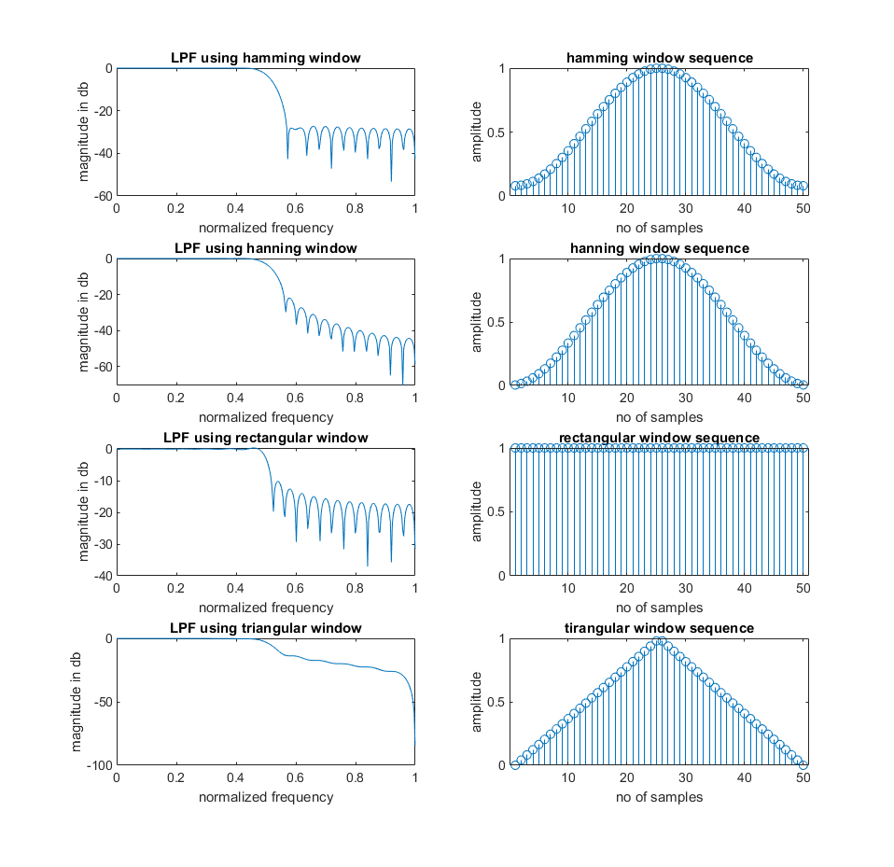

1. High Pass Filter

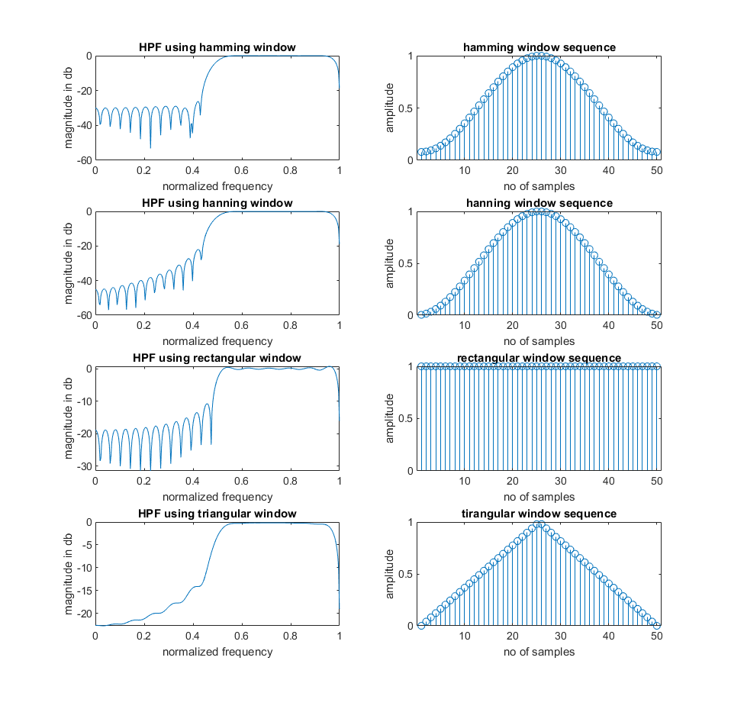

1. Band Pass Filter

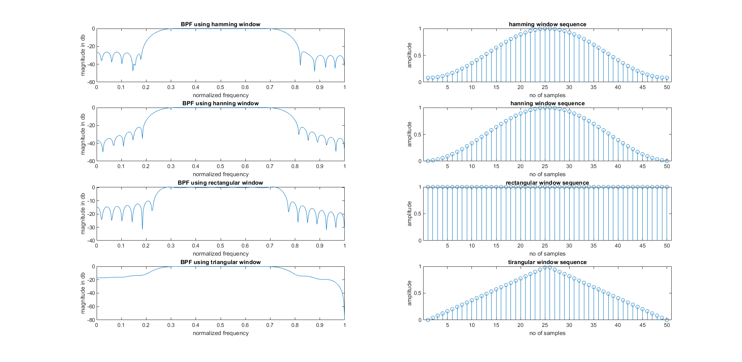

1. Band Stop Filter

